**SMART DISTANCE METER**

**Introduction**

Ultrasonic sensors are great tools to measure distance without actual contact and used at several places like water level measurement, distance measurement etc. This is an efficient way to measure small distances precisely. In this project we have used an Ultrasonic Sensor to determine the distance of an obstacle from the sensor. Basic principle of ultrasonic distance measurement is based on ECHO. When sound waves are transmitted in environment then waves are return back to origin as ECHO after striking on the obstacle. So we only need to calculate the travelling time of both sounds means outgoing time and returning time to origin after striking on the obstacle. As speed of the sound is known to us, after some calculation we can calculate the distance.

Nowadays, measuring distance is considered as problem in construction field or indoor measuring activities because this task is made by using measuring tape. The problem will occur when using measuring tape where we need at least 2 persons to measure between two distances. Besides, it is not have a perfect accuracy due to parallax and obstacle in their way. Improvement had been done where some products have infrared light emitters and receivers to determine an object's distance. Other devices have laser-based systems which have improved accuracy and precision. Presently, the detection techniques of laser, radar, and infrared ray have been widely applied at the aspect of obstruction detection and distance measurement. Because of the expensive price, the distance measurement system of laser and radar is only set on the minority of instruments. For infrared sensor, the range of the distance that can be measured is very short with only a range of 4-30 cm

**Why did we decide to make this project:**

* Distance Meter allows you to measure the approximate distance and height of an object with using arduino, ultrasonic sensor and LCD screen.
* To get an accurate measurement.
* To inform user about the total distance by displaying on Liquid Crystal Display (LCD).

**Materials and Methods**

**Components Used:**

* HARDWARE

|  |  |  |  |
| --- | --- | --- | --- |
| **S no.** | **Name of the Component** | **Picture** | **Description** |
| 1. | PCB Board |  | A printed circuit board (PCB) mechanically supports and electrically connects electronic components or electrical components using conductive tracks, pads and other features etched from one or more sheet layers of copper laminated onto and/or between sheet layers of a non-conductive substrate. |
| 2. | Ultrasonic Sensor (HC-SR04) |  | **HC-SR04 Ultrasonic (US) sensor** is a 4 pin module, whose pin names are Vcc, Trigger, Echo and Ground respectively. This sensor is a very popular sensor used in many applications where measuring distance or sensing objects are required. The module has two eyes like projects in the front which forms the Ultrasonic transmitter and Receiver. The sensor works with the simple formula that  **Distance = Speed × Time**  The Ultrasonic transmitter transmits an ultrasonic wave, this wave travels in air and when it gets objected by any material it gets reflected back toward the sensor this reflected wave is observed by the Ultrasonic receiver module |
| 3. | Arduino UNO | Image result for arduino uno board | Arduino UNO Board is a widely used open source microcontroller board based on the Atmega328P microcontroller and developed by Arduino.cc. The board is equipped with sets of digital and analog equipments. The board features 14 digital pins and 6 Analog pins. It is programmable with the Arduino IDE (Integrated Development Environment) via a type B USB cable. It can be powered by USB cable or by external 9 volt battery. |
| 4. | LCD Screen |  | LCD (Liquid Crystal Display) screen is an electronic display module and find a wide range of applications. A 16x2 LCD display is very basic module and is very commonly used in various devices and circuits. These modules are preferred over seven segments and other multi segment LEDs. |
| 5. | Battery 9V |  | The nine-volt battery, or 9-volt battery, is a common size of battery that was introduced for the early transistor radios. It has a rectangular prism shape with rounded edges and a polarized snap connector at the top. This type is commonly used in walkie-talkies, clocks and smoke detectors |
| 6. | Potentiometer |  | A potentiometer is a three-terminal resistor with a sliding or rotating contact that forms an adjustable voltage divider. If only two terminals are used, one end and the wiper, it acts as a variable resistor or rheostat.  The principle of the potentiometer is that: For a wire having uniform area of cross section and uniform composition,the potential drop is directly proportional to the length of wire. The above principle is valid when potentiometer is used in comparing the EMF of two cells. |

* SOFTWARE

1. Arduino IDE

The **Arduino integrated development environment (IDE)** is a cross-platform application (for Windows, macOS, Linux) that is written in the programming language Java. It is used to write and upload programs to Arduino board.

2. Fritzing

Fritzing is an open source hardware initiative that makes electronics accessible as a creative material for anyone. It is a software tool and a community website for processing and Arduino ,fostering a creative ecosystem that allows users to document their prototypes, share them with others ,teach electronics in classroom, and layout and manufacture professional pcbs.

**Method**

Step 1:

The ultrasonic sensor echo pin and trigger pin is connected to pin digital pin D4 and D2 respectively

Step 2:

Ultrasonic sensor HC-SR04 module is used to locate the distance between the object and the sensor. When this sensor verifies the presence obstacle it starts to send eight cycles of ultrasonic burst at 40 KHz and then it waits for reflected ultrasonic signal

Step 3:

Control pin RS, RW and En are directly connected to arduino pin 5, GND and 6. And data pin D4-D7 is connected to 7, 8, 9 and 10 of arduino

Step 4:

First of all we need to trigger the ultrasonic sensor module to transmit signal by using arduino and then wait for receive ECHO. Arduino reads the time between triggering and Received ECHO. We know that speed of sound is around 340m/s. so we can calculate distance by using given formula:

Distance= (travel time/2) * speed of sound, where speed of sound around 340m per second.

A 16x2 LCD is used for displaying distance.

**Schematics**

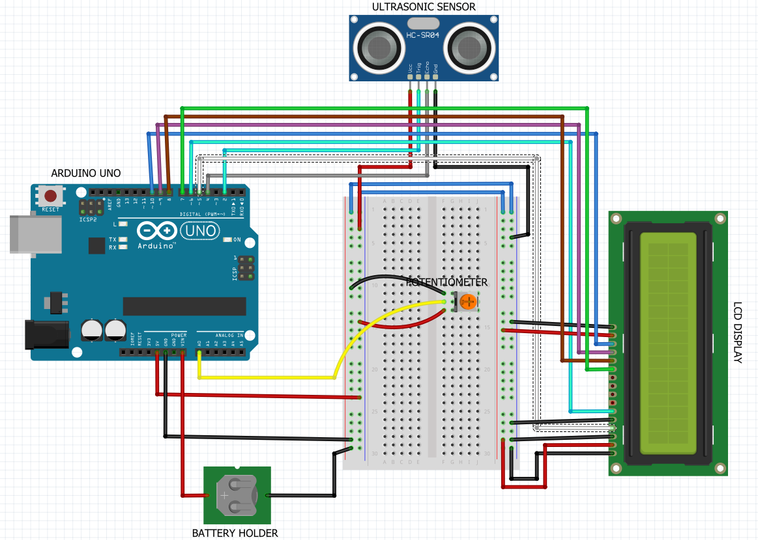

**Cad Model**

**Future Scope**

* New prototyping hardware & compatibility & interfacing with other consumer electronic/tv/smartphones & flooding of shields.
* Mining equipments may require where entail
* Acready compatible with many major simulation software like MATLAB & lab view, we may see even move flexible programming environment & development option
* Using temp. Compensation, it can be used over wide temp range.
* Height measurement, agriculture velide, collision /protection can be other application.